Software Architecture Document
Project Name: Xin1 Integrated Powertrain Domain Controller
Technology Owner:
Version: V001
Document No: Xin1_SAD_001

Change History
Version | Date | Author | Reviewer | Approver | Change description
001 | 13/08/2026 | Ratneswar Sahoo | Pankaj D | Rajiv Kumar | Initial Draft

TABLE OF CONTENTS
1 Introduction 4
1.1 Document scope 4
1.2 Terminologies 4
2 Software Requirements 5
2.1 Software overview 5
3 Software Architecture 5
3.1 Introduction 5
3.2 Block diagram/ boundary diagram 5
3.3 Software architecture elements 5
3.4 Software Relationship 5
3.5 Software FuSa and Cyber Security Characteristics 6
3.6 Performance Characteristics 6
3.7 Data parameters 6
3.8 Data Corruption Checks 6
3.9 Operating System Task Structure 6
3.10 Interrupts 7
3.11 Dynamic behavior of the Software and its elements 7
3.12 Operation mode and its dependencies 7
3.13 Resource consumption objective 7
3.14 Software Variants 8
4 Software Integration plan 8
4.1 Software Integration Approach 8
5 Generic Requirements 8
5.1 Tata Motors Generic Requirements 8
5.2 Relevant Industry Standards 9
6 Software Architecture Signoff details 9

Introduction

Document scope
This Software Architecture Document defines the software architecture of the Xin1 Integrated Electric Vehicle Powertrain Domain Controller.
The document establishes:
- software architectural elements
- software responsibilities
- allocation of software elements to Main CPU and Sub CPU
- interfaces and interactions between software elements
- interfaces with hardware, external systems and other ECUs
- functional safety and cybersecurity architectural characteristics
- performance and timing characteristics
- data and persistence architecture
- operating system task structure
- interrupt structure
- dynamic software behaviour
- operating modes and dependencies
- resource consumption objectives
- software variants
- Software integration approach.

Terminologies
Acronym | Definition
EVCU | Electric Vehicle Control Unit
BMS | Battery Management System
HPC | High Performance Controller
CCS2 | Combined Charging System Type-2
HVIL | High Voltage Interlock Loop
DCDC | DC/DC Converter
OBD | On Board Diagnostics
OTA | Over-The-Air Update
UDS | Unified Diagnostic Services
CAN | Controller Area Network
PLC | Power Line Communication
ASIL | Automotive Safety Integrity Level
ASW | Application Software
BSW | Base Software
EOL | End of Line
HIL | Hardware in the Loop
MIL | Model in the Loop
SIL | Software in the Loop
NVM | Non-Volatile Memory
OS | Operating System
SWC | Software Component
WCET | Worst-Case Execution Time
RTE | Runtime Environment
BCS | Battery Cooling System
TCS | Cooling System
PDU | Power Distribution Unit
EVCC | Electric Vehicle Charging Controller
Terminologies

Software Requirements

Software overview
The Xin1 software is a distributed multicore software system executing across the Main CPU and Sub CPU.
Traction Inverter software, EVCU software and common platform software required by the above functions are executed in Main CPU. Steering inverter software, Brake inverter software, DCDC software, common platform software required by the above functions are executed in Sub CPU.
Software also interacts with their respective power boards within the System boundary and externally interacts with BMS, BCS, TCS, PDU, EVCC, vehicle network, diagnostic interface, HVIL, vehicle HMI and external vehicle systems.

Software Modules / Elements
Please refer to section 3.3 for Software Modules/Elements.

Reference of document

Software Requirement document
Please refer to “Software Requirement Document_SQGP_V001”.

Software Architecture

Introduction
The Xin1 software architecture shall provide a structured decomposition of the software into architectural elements that:
- implement the software requirements
- execute on the appropriate processor/core
- provide defined interfaces
- support functional-safety requirements
- support cybersecurity requirements
- satisfy timing and performance requirements
- support diagnostics and software updates
- provide controlled access to hardware resources
- Permit incremental integration and verification.

Block diagram/ boundary diagram

Software architecture elements
Element Number | Element | Sub element
SW-ARCH-001 | Main CPU Application Layer | EVCU Application
 |  | Traction Control Application
 |  | Main CPU Safety Application
SW-ARCH-002 | Sub CPU Application Layer | Steering Control Application
 |  | Brake Control Application
 |  | DCDC Control Application
 |  | Sub CPU Safety Application
SW-ARCH-003 | Communication Services | CAN Communication
 |  | Ethernet Communication
 |  | Inter CPU Communication
 |  | Network Management
SW-ARCH-004 | Diagnostic Services | UDS Diagnostic
 |  | DTC Management
 |  | Diagnostic Session Management
SW-ARCH-005 | NVM / Persistence Services | Configuration Data
 |  | Calibration Data
 |  | Diagnostic Data
SW-ARCH-006 | Safety Services | Safety Monitoring
 |  | Fault Handling
 |  | Safe State Management
SW-ARCH-007 | Cybersecurity Services | Secure Access
 |  | Software Integrity
 |  | Security Event Handling
SW-ARCH-008 | System Services | Initialization
 |  | Operating Mode Management
 |  | Time Management
 |  | Watchdog Supervision
SW-ARCH-009 | RTE | Application-to-Service Communication
SW-ARCH-010 | AUTOSAR BSW | OS
 |  | Communication Stack
 |  | Diagnostic Stack
 |  | NVM Stack
 |  | ECU State Manager
SW-ARCH-011 | MCAL / Hardware Abstraction | ADC
 |  | PWM
 |  | CAN
 |  | Ethernet
 |  | Timers
 |  | GPIO
 |  | SPI
 |  | I2C
 |  | UART
 |  | Other required peripherals
Software Architecture elements

Software Relationship

Relationship of software elements (including interfaces and interactions)
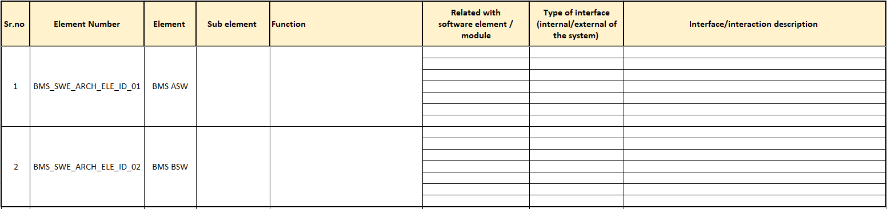
Sl. No. | Element Number | Element | Sub Element | Function | Related with SW element/module | Type of interface (Int/Ext) | Interface/interaction description

Allocation matrix

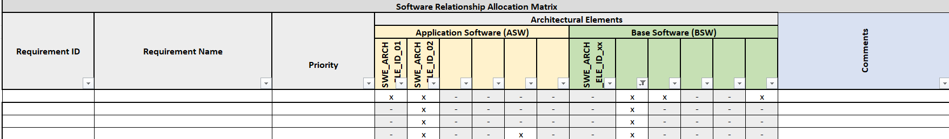
Requirement ID | Requirement Name | Priority

Software FuSa and Cyber Security Characteristics

Performance Characteristics
- Efficiency –
- Compliance –
- Coverage –

Data parameters
Data parameters are defined and categories as per the persistency in the following table:
Sr. No | Data | Category | Condition
1 | E.g SOC | Persistent | Power down cycle
2
3
4
List of database and persistent parameters

Data Corruption Checks

Operating System Task Structure
Operating system task structure define in following table:
Sr. No. | Tasks | Priority | Operations
1 | E.g Initialization | High | HVIL Monitoring
Operating System Task Structure

Interrupts
S.No. | Interrupt | Priority* | Description | Event
1 | E.g Timer | 1 | Timer 10ms interrupt | Compare the events
2
3
4
Interrupts

Dynamic behavior of the Software and its elements

Operation mode and its dependencies
Operation | State | Command | Time (msec) | Description
Operating Modes in BMS

Resource consumption objective
Memory | Consumption objective
Resource consumption

Memory Mapping

Memory Arrays(or Banks) | Block Number | Sector Number | Segment Size | Low Address | High Address | Memory used for
Memory Layout of Flash Memory

Software Variants

Software Integration plan

Software Integration Approach

Software Integration steps and their sequence
Software integration steps release plan shown below:
Software Integration Steps | Release Plan
Software Integration steps release plan

Software Architectural required elements for integration steps

Element Number | Element | Sub element | Release Plan / DR gateway
Software architectural required elements for integration plan

Preconditions for integration of software items

Generic Requirements

Tata Motors Generic Requirements
Document Number | Definition
List of Tata Motors generic requirements

Relevant Industry Standards
Document Version | Definition
List of Tata Motors generic requirements

Software Architecture Signoff details

Sr.no | Function | Name | Designation
1
2
3
4
List of stakeholders for signoff

